Name_______________________________

# Lab 17: Intro to Spatial SQL

In this lab students will learn to connect to a PostGIS database and perform simple SQL queries using QGIS.

## Part I: Adding a PostGIS Database Connection to QGIS

1. 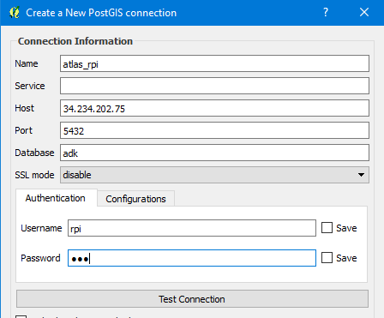Open up a new QGIS project and add a basemap from the Open Layers plugin.
2. Go to Layer🡪Add Layer🡪**Add PostGIS Layers** and click ‘New’
3. Fill in the dialogue as shown to the right, with password ‘rpi’
4. Click ‘Test Connection’ if it succeeds, click OK and close the dialogue.

## Part II: Adding layers from a PostGIS database to QGIS

1. Go to Database🡪DB Manager🡪DB Manager
2. Click the carat (>) next to ‘atlas_rpi’ in the tree to connect to the database. Note: all tables in the api schema are in the WGS84 projection (4326)
3. Expand the schema named ‘api’ and right-click the ‘points’ layer and select ‘add to canvas’. You should see the layer appear in the QGIS map. Check out the attribute table.
4. Back in the DB Manager, click the ‘SQL Window’ button 
5. Try pasting Query A on the next page into the sql window and hitting the ‘Execute’ button. You should see the results appear below your sql.
6. Check the ‘Load as new layer’ box and select the appropriate fields for unique identifier and geometry column.
7. Pick a Layer Name (e.g. campsites) and click the ‘Load Now’ button.
8. Check out the layer in the map… did it work?
9. Repeat this process with the queries B and C.
10. **Create a query that returns all summits intersecting Wild Forest areas.**

**Query A:**

**SELECT a.uid,**

**a.name,**

**a.geom**

**FROM api.points a**

**WHERE a.keywords ilike '%campsite%'**

**ORDER BY a.name**

**Query B:**

**SELECT a.uid,**

**a.name,**

**a.geom**

**FROM api.points a, api.units b**

**WHERE ST_Intersects(a.geom,b.geom)**

**AND a.keywords ilike '%campsite%'**

**AND b.name='High Peaks Wilderness'**

**Query C:**

**SELECT a.uid,**

**a.name,**

**ST_Buffer(**

**ST_Transform(a.geom,3857)**

**,200) AS geom**

**FROM api.points a, api.units b**

**WHERE ST_Intersects(a.geom,b.geom)**

**AND a.keywords ilike '%campsite%'**

**AND b.name='High Peaks Wilderness’**